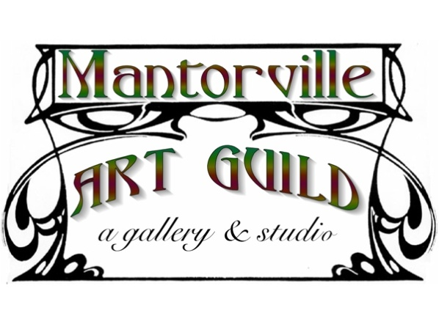

P.O. Box 224 521 North Main Street
Mantorville, Minnesota 55955
507/635-5665
www.mantorvilleartguild.org

The Mantorville Art Guild is seeking participants
for its annual Stagecoach Days Art & Fine Crafts Show
June 25 & 26, 2016
Mantorville Stagecoach Days, sponsored by the Mantorville Economic Development Alliance, explores the life style and pastimes of Mantorville and Southeastern Minnesota from the mid-1800’s until the early 1900’s. Over past three years, event planners have brought new life to this celebration with the addition of a costume contest and live music. These events along with the tractor pull, the melodrama at the Opera House and the Mantorville Art Guild’s Stagecoach Days Art Show truly do celebrate Mantorville’s colorful past. Attendance last year doubled! Join us for a weekend of Olde Tyme fun!

While the emphasis of this weekend is on tradition and history, all art forms, mediums and fine crafts are welcome. The Art Show is held on the lawn of the Gallery Building and spaces are 10’ x10’. Artists NO wholesale, buy/sell! All Items must be handcrafted! Space limited to 20 -25 artisans.
Fill out this application and return it, along with your MNST-19 and your fee to
Mantorville Art Guild, PO Box 224, Mantorville, MN 55955.
Deadline for application is June 1

♦ You must have a MNST-19 Sales Tax Form.
♦ All items for sale must be artist made. New artists will be juried as their applications are received.
♦ Cost for each 10’ X 10’ space is $50.00. Spaces assigned on a first come first served basis.
♦ Set up begins at 8AM, Saturday June 25, unless special arrangements are made with the MAG Event Coordinator. Vendors are expected to remain until 4PM on Sunday.
♦ Historic costumes (1850’s-1900) are encouraged but not required. Limited electricity is available. Restroom facilities, refrigeration and drinking water on site.
www.mantorvilleartguild.org or www.mantorvilletourism.com for more information.

P.O. Box 224 521 North Main Street
Mantorville, Minnesota 55955
507/635-5665
www.mantorvilleartguild.org

MANTORVILLE
STAGECOACH DAYS
ART & Fine Crafts SHOW
JUNE 25 & 26, 2016

Name (Please Print) _________________________________________________________

Number of Spaces Needed __________________ Amount Enclosed

Items for Sale____________________________________________________________

MN Tax Number________________ Please fill out and return MN Sates Tax Form ST19 with your registration.

Mailing Address __________________________________________________________

__________________________________________________________

Phone ________________________Email _____________________________________

Signed ________________________________________________

Name (Please Print) _________________________________________________________

Items for Sale____________________________________________________________

MN Tax Number________________ Please fill out and return MN Sates Tax Form ST19 with your registration.

Mailing Address __________________________________________________________

__________________________________________________________

Phone ________________________Email _____________________________________

Signed ________________________________________________

Name (Please Print) _________________________________________________________

Items for Sale____________________________________________________________

MN Tax Number________________ Please fill out and return MN Sates Tax Form ST19 with your registration.

Mailing Address __________________________________________________________

__________________________________________________________

Phone ________________________Email _____________________________________

Signed ________________________________________________

Name (Please Print) _________________________________________________________

Items for Sale____________________________________________________________

MN Tax Number________________ Please fill out and return MN Sates Tax Form ST19 with your registration.

Mailing Address __________________________________________________________

__________________________________________________________

Phone ________________________Email _____________________________________

Signed ________________________________________________

Name (Please Print) _________________________________________________________

Items for Sale____________________________________________________________

MN Tax Number________________ Please fill out and return MN Sates Tax Form ST19 with your registration.

Mailing Address __________________________________________________________

__________________________________________________________

Phone ________________________Email _____________________________________

Signed ________________________________________________

Name (Please Print) _________________________________________________________

Items for Sale____________________________________________________________

MN Tax Number________________ Please fill out and return MN Sates Tax Form ST19 with your registration.

Mailing Address __________________________________________________________

__________________________________________________________

Phone ________________________Email _____________________________________

Signed ________________________________________________

Name (Please Print) _________________________________________________________

Items for Sale____________________________________________________________

MN Tax Number________________ Please fill out and return MN Sates Tax Form ST19 with your registration.

Mailing Address __________________________________________________________

__________________________________________________________

Phone ________________________Email _____________________________________

Signed ________________________________________________

